**A Project Report**

On

**"FASHION LENS"**

By

**"INDRAJIT SHIVRAJ CHAVAN"**

MCA Trimester-VI

17MCA018

**Batch – 2017-20**

Under the guidance of

**Dr. Ashish Kulkarni**

**Programme Head - MCA**

Submitted to



In partial fulfilment of the requirement for the award of

Degree of Master of Computer Application (MCA)

**MITWPU’s School of Management, Kothrud, Pune.**

Certificate

This is to certify that the Project Report entitled **“Fashion Lens”** is prepared by **“Indrajit Shivraj Chavan”** **“17MCA018”** of MITWPU School of Management MCA-II Trimester-VI during the Academic Year 2017-18 and the same has been examined and duly signed.

The Project Report of **MCA-6005 Mini Project on Android** submitted in partial fulfilment of MCA Programme for the academic year 2017-18 as per the rules and prescribed guidelines of MITWP University.

|  |  |  |
| --- | --- | --- |
| **Mr. Yusuf Patrawala** |  | |
| **Internal Guide** |  | |
| **Prof. Dr. Sayalee Gankar** | |
| **Dean Management**  **(PG Programmes) MITWPU** | |

Date:

Place: Pune

Examined by:

Examiner 1

Examiner 2

Declaration

This declaration is part of the project work entitled ‘FASHION LENS’ is submitted as part of academic requirement for Trimester VI of MCA to the MITWP University.

I, *Indrajit Shivraj Chavan, 17MCA018* solely declare that

1. I have not used any unfair means to complete the project.
2. I have followed the discipline and the rules of the organization where I was doing the project.
3. I have not been part of any act which may impact the institute reputation adversely.

The information I have given is true, complete and accurate. I understand that failure to give truthful, incomplete and inaccurate information may result in cancellation of my project work.

Date:

Place: Name and Signature of Student

**INDEX**

|  |  |  |
| --- | --- | --- |
| **Sr. No** | **Content** | **Page No.** |
| **1** | **Introduction**   * **Objective** * **Scope of the Project** |  |
| **2** | **Requirements**   * + **Hardware and Software**   + **User requirements** |  |
| **3** | **Procedure & Design**   * **Project Process** * **Retraining the Network - Transfer Learning** * **Analyze Results** |  |
| **4** | **Annexure 2: Accuracy & Cross Entropy Graph Outputs** |  |

**INTRODUCTION**

**With** the dawn of a new era of A.I., machine learning, and robotics, it’s time for the machines to perform tasks characteristic of human intelligence. Machines use their own senses to do things like planning, pattern recognizing, understanding natural language, learning and solving problems. And Image Recognition is one of its senses!!!

From Automated self-driven cars to Boosting augmented reality applications and gaming, from Image and Face Recognition on Social Networks to Its application in various Medical fields, Image Recognition has emerged as a powerful tool and has become a vital for many upcoming inventions.

Image recognition is a great task for developing and testing machine learning approaches. Vision is debatably our most powerful sense and comes naturally to us humans. But how do we actually do it? How does the brain translate the image on our retina into a mental model of our surroundings? I don’t think anyone knows exactly. The point is, it’s seemingly easy for us to do - so easy that we don’t even need to put any conscious effort into it - but difficult for computers to do (Actually, it might not be that easy for us either, maybe we’re just not aware of how much work it is. More than half of our brain seems to be directly or indirectly involved in vision).

How can we get computers to do visual tasks when we don’t even know how we are doing it ourselves? That’s where machine learning comes into play. Instead of trying to come up with detailed step by step instructions of how to interpret images and translating that into a computer program, we’re letting the computer figure it out itself. The goal of machine learning is to give computers the ability to do something without being explicitly told how to do it. We just provide some kind of general structure and give the computer the opportunity to learn from experience, similar to how we humans learn from experience too.

**What is Transfer Learning?**

Transfer learning is a machine learning technique where a model trained on one task is re-purposed on a second related task.

*Transfer learning and domain adaptation refer to the situation where what has been learned in one setting … is exploited to improve generalization in another setting*

Transfer learning is an optimization that allows rapid progress or improved performance when modelling the second task.

*Transfer learning is the improvement of learning in a new task through the transfer of knowledge from a related task that has already been learned.*

Transfer learning is related to problems such as multi-task learning and concept drift and is not exclusively an area of study for deep learning.

Nevertheless, transfer learning is popular in deep learning given the enormous resources required to train deep learning models or the large and challenging datasets on which deep learning models are trained.

Transfer learning only works in deep learning if the model features learned from the first task are general.

*In transfer learning, we first train a base network on a base dataset and task, and then we repurpose the learned features, or transfer them, to a second target network to be trained on a target dataset and task. This process will tend to work if the features are general, meaning suitable to both base and target tasks, instead of specific to the base task.*

**How to Use Transfer Learning?**

You can use transfer learning on your own predictive modelling problems.

Two common approaches are as follows:

1. Develop Model Approach
2. Pre-trained Model Approach

**Develop Model Approach**

1. **Select Source Task**. You must select a related predictive modelling problem with an abundance of data where there is some relationship in the input data, output data, and/or concepts learned during the mapping from input to output data.
2. **Develop Source Model**. Next, you must develop a skilful model for this first task. The model must be better than a naive model to ensure that some feature learning has been performed.
3. **Reuse Model**. The model fit on the source task can then be used as the starting point for a model on the second task of interest. This may involve using all or parts of the model, depending on the modelling technique used.
4. **Tune Model**. Optionally, the model may need to be adapted or refined on the input-output pair data available for the task of interest.

**Pre-trained Model Approach**

1. **Select Source Model**. A pre-trained source model is chosen from available models. Many research institutions release models on large and challenging datasets that may be included in the pool of candidate models from which to choose from.
2. **Reuse Model**. The model pre-trained model can then be used as the starting point for a model on the second task of interest. This may involve using all or parts of the model, depending on the modelling technique used.
3. **Tune Model**. Optionally, the model may need to be adapted or refined on the input-output pair data available for the task of interest.

This second type of transfer learning is common in the field of deep learning.

**Examples of Transfer Learning with Deep Learning**

Let’s make this concrete with two common examples of transfer learning with deep learning models.

**Transfer Learning with Image Data**

It is common to perform transfer learning with predictive modelling problems that use image data as input.

This may be a prediction task that takes photographs or video data as input.

For these types of problems, it is common to use a deep learning model pre-trained for a large and challenging image classification task such as the ImageNet 1000-class photograph classification competition.

The research organizations that develop models for this competition and do well often release their final model under a permissive license for reuse. These models can take days or weeks to train on modern hardware.

These models can be downloaded and incorporated directly into new models that expect image data as input.

Three examples of models of this type include:

* Oxford VGG Model
* Google Inception Model
* Microsoft ResNet Model

This approach is effective because the images were trained on a large corpus of photographs and require the model to make predictions on a relatively large number of classes, in turn, requiring that the model efficiently learn to extract features from photographs in order to perform well on the problem.

In their Stanford course on Convolutional Neural Networks for Visual Recognition, the authors caution to carefully choose how much of the pre-trained model to use in your new model.

*[Convolutional Neural Networks] features are more generic in early layers and more original-dataset-specific in later layers*

— Transfer Learning, CS231n Convolutional Neural Networks for Visual Recognition

**Transfer Learning with Language Data**

It is common to perform transfer learning with natural language processing problems that use text as input or output.

For these types of problems, a word embedding is used that is a mapping of words to a high-dimensional continuous vector space where different words with a similar meaning have a similar vector representation.

Efficient algorithms exist to learn these distributed word representations and it is common for research organizations to release pre-trained models trained on very large corpa of text documents under a permissive license.

Two examples of models of this type include:

* Google’s word2vec Model
* Stanford’s GloVe Model

These distributed word representation models can be downloaded and incorporated into deep learning language models in either the interpretation of words as input or the generation of words as output from the model.

In his book on Deep Learning for Natural Language Processing, Yoav Goldberg cautions:

*… one can download pre-trained word vectors that were trained on very large quantities of text […] differences in training regimes and underlying corpora have a strong influence on the resulting representations, and that the available pre-trained representations may not be the best choice for [your] particular use case.*

— Page 135, Neural Network Methods in Natural Language Processing, 2017.

**When to Use Transfer Learning?**

Transfer learning is an optimization, a shortcut to saving time or getting better performance.

In general, it is not obvious that there will be a benefit to using transfer learning in the domain until after the model has been developed and evaluated.

Lisa Torrey and Jude Shavlik in their chapter on transfer learning describe three possible benefits to look for when using transfer learning:

1. **Higher start**. The initial skill (before refining the model) on the source model is higher than it otherwise would be.
2. **Higher slope**. The rate of improvement of skill during training of the source model is steeper than it otherwise would be.
3. **Higher asymptote**. The converged skill of the trained model is better than it otherwise would be.

Ideally, you would see all three benefits from a successful application of transfer learning.

It is an approach to try if you can identify a related task with abundant data and you have the resources to develop a model for that task and reuse it on your own problem, or there is a pre-trained model available that you can use as a starting point for your own model.

On some problems where you may not have very much data, transfer learning can enable you to develop skilful models that you simply could not develop in the absence of transfer learning.

The choice of source data or source model is an open problem and may require domain expertise and/or intuition developed via experience.

**SCOPE OF THE PROJECT**

**Online Fashion Industry *‘High on AI’***

Subtlety and innovation are the core of all AI-powered marketing techniques; even though the results may not show immediately, it would not be an exaggeration to say that AI is slowly yet steadily shaping the way customers shop apparel and other lifestyle products online. Off late, we have seen many e-commerce websites adopting deep learning (a part of AI) to help people find what they are seeking over the long-term, and unlike when done manually, there is negligible scope of error in the analysis. It doesn’t only end there.

To bring this closer to online retail experience, online shopping websites are nowadays even recommending products based on a person’s buying history or requirement. For instance, the next time you shop a pink lehenga from an e-tailor, the very same day the website may show you some matching artificial jewellery sets to complement your outfit.

AI enables every e-retailer to provide enriching and game-changing experiences to their customers, and that too, without compromising on their online security at all (some of these high-end technologies do not even need to physically browse the online store to synthesize the data).While some may say that all of this is unnecessary voyeurism into human minds, in reality it earns loyalty and delight from a large pool of customers. It’s no rocket science why—everyone in the online universe nowadays wants a personalized service experience, and embracing AI-driven insights into your online fashion brand’s CRM (Customer Relationship Management) agenda leaves your brand empowered.

Besides, a lot of e-com fashion websites are nowadays overloaded with orders and sheer sales volumes become difficult to manage; this is where adequate customization and segmentation can help reach operational efficiency up to the optimum level, all thanks to AI. According to reports, solely artificial intelligence-based start-ups in India have now even started partnering with e-commerce platforms for providing the latter’s back-end technology support, and such synergies are bringing the best of both worlds online.

**Requirements**

**Hardware and Software**

***User requirements***

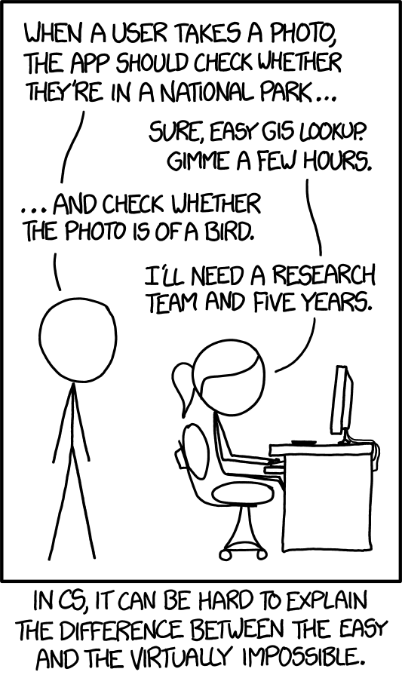

**Procedure & Design**